FRAUD CASH DETECTION USING IMAGE PROCESSING
A Major Project Report
Submitted in partial fulfillment of the requirements for the award of the degree of

Bachelor of Engineering
in

Computer Science and Engineering

By

PATHLAVATH DIVYA 2456-21-733-046
GUNDUPALLI THANUSHA 2456-21-733-020
GADIRAJU SRAVYA SANTHOSHI 2456-21-733-016

Under the guidance of Mrs. N. MEGHANA

Assistant Professor



DEPARTMENT OF COMPUTER SCIENCE AND ENGINEERING

Gokaraju Lailavathi Engineering College

(Affiliated to Osmania University)

GRIET Campus , Bachupally , Kukatpally , Hyderabad-500090 (2024-2025)

Department of Computer Science and Engineering
Gokaraju Lailavathi Engineering College
(Affiliated to Osmania University)
GRIET Campus, Bachupally, Kukatpally, Hyderabad-500090(2024-2025)

CERTIFICATE
This is to Certify that A Major Project report entitled “Fraud Cash Detection using Image Processing” is being submitted by Pathlavath Divya (2456-21-733-046), Gundupalli Thanusha (2456-21-733-020), Gadiraju Sravya Santhoshi (2456-21-733-016) in partial fulfillment of the requirement of the award for the degree of Bachelor of Engineering in “Computer Science and Engineering” O.U., Hyderabad during the year 2024-2025 is a record of Bonafide work carried out by them under my guidance. The results presented in this project have been verified and are found to be satisfactory.

Project Guide H.O.D
Mrs. N. Meghana Dr. Padmalaya Nayak
Assistant Professor, Professor & Head, Dept of CSE Dept. of CSE

External Examiner(s)

Department of Computer Science and Engineering
Gokaraju Lailavathi Engineering College
(Affiliated to Osmania University)
GRIET Campus, Bachupally,
Kukatpally, Hyderabad-
500090(2024-2025)
DECLARATION

We, Pathlavath Divya bearing Ht.No.2456-21-733-046, Gundupalli Thanusha bearing Ht.No.2456-21-733-020 and Gadiraju Sravya Santhoshi bearing Ht.No.2456-21-733-016 hereby certify that the major project entitled “FRAUD CASH DETECTION USING IMAGE PROCESSING” is submitted in the partial fulfilment of the required for the award of the degree of Bachelor of Engineering in Computer Science and Engineering.
This is a record work carried out by us under the guidance of Mrs. N. Meghana, Assistant Professor, CSE, Gokaraju Lailavathi Engineering College, Hyderabad. The results embodied in this report have not been reproduced/copied from any source. The results embodied in this report have not been submitted to any other university or institute for the award of any other degree or diploma.

ACKNOWLEDGEMENT

It is our privilege and pleasure to express my profound sense of respect, gratitude and indebtedness to our guide Mrs. N Meghana, Assistant Professor, Department of Computer Science and Engineering, Gokaraju Lailavathi Engineering College, for her inspiration, guidance, cogent discussion, constructive criticisms and encouragement throughout this dissertation work.
We sincerely thank our Project Coordinator, Dr Ushasree, Assistant Professor, Department of Computer Science and Engineering, Gokaraju Lailavathi Engineering College, for her valuable suggestions and constant help in completing the work.
We express our sincere thanks to Project Coordinator Dr. Padmalaya Nayak, Professor and Head of Department of Computer Science and Engineering, Gokaraju Lailavathi Engineering College, for their valuable suggestions and constant helping in completing the work.
We express our sincere thanks to Dr. Akundi Sai Hanuman, Principal, Gokaraju Lailavathi Engineering College, Hyderabad for his encouragement and constant help.
We extend our sincere thanks to all the teaching staff of Computer Science and Engineering Department for their support and encouragement.
Last but not least, we wish to acknowledge my friends and family members for giving moral strength moral strength and helping us to complete this dissertation.

ABSTRACT

The rising cases of the bootleg money are a clear danger to the economic well-being of people and the confidence of the society in the economy. The project as stated is one that will build a dependable and automated fraudulent cash solving framework that will leverage the frame of image processing and machine learning. This system will examine banknote images in high resolution and select features in regards to its color composition and distribution, the physical aspects such as its texture as well as its watermark areas and security features written into it (or not). A vast number of image processing techniques will be employed by the system to pre-process and to improve on the images of banknote such as edge detection, histogram analysis and detection of regions using the contour method. The measurements extracted during processing and enhancing the images of the banknote will be utilized to train an artificial intelligence (AI) model which can either be, a Support Vector Machine (SVM), or Convolutional Neural Network (CNN) trained to either classify genuine or counterfeit banknotes. The suggested automated cash detection and fraud currency detection algorithm would build an inexpensive, effective, and scalable system which would address real-time verification in cash and this could be employed in banks, automated teller machines (ATM) and even commercially in many business ventures to protect against monetary frauds. In this project, the analysis of fake currency was done based on the technique of image processing and machine learning. The machine captures the images of money notes, captures and examines the pictures to identify the main characteristics of the notes, such as patterns, colors, textures and the security markings. The processing of images can be employed to filter and extract features out of an image, and such features can be employed to train a model with the help of machine learning to classify the currency notes as real or fake. The end product of this entire development is a very highly precise, fast and effective automatic verification currency method or strategy that will enable efforts to be made to ensure that the chances of fraud are minimized in the banks, the shops and the entire monetary system in general.

CONTENTS

Chapter-1 INTRODUCTION 1
  - MOTIVATION… 1
  - PROBLEM STATEMENT… 1
  - PROJECT OBJECTIVE… 2
Chapter-2 LITERATURE SURVEY 3
  - EXISTING SYSTEM… 4
  - LIMITATIONS OF EXISITNG SYSTEM… 4
Chapter-3 SOFTWARE REQUIREMENT SPECIFICATION 5
  - SOFTWARE REQUIREMENTS… 5
  - HARDWARE REQUIREMENTS………………………………………………………..5
  - FUNCTIONAL REQUIREMENTS 5
  - NON-FUNCTIONAL REQUIREMENTS…......................................................................6
Chapter-4 SYSTEM DESIGN 7
  - SYSTEM DESIGN… 7
  - SYSTEM ARCHITECTURE………………………………………………………….…8
  - UML DESIGN… 8
    - ACTIVITY DIAGRAM… 11

    - USECASE DIAGRAM… 12
    - COMPONENT DIAGRAM… 13
    - SEQUENCE DIAGRAM… 14
    - STATE CHART DIAGRAM… 15
  - TECHNOLOGY DESCRIPTION… 16
Chapter-5 IMPLEMENTATION 19
  - OBJECTIVES AND SCOPE… 19
  - MODULES… 21
  - EXECUTABLE CODE… 22
Chapter-6 TESTING 31
  - TESTING DEFINATION… 31
  - UNIT TESTING…..........................................................................................................31
  - FUNCTIONAL TESTING……………………………………………………………...32
Chapter-7 RESULTS 33
Chapter-8 CONCLUSION 35
  - CONCLUSION… 35
  - FUTURE SCOPE… 35
REFERENCES 35

SNO. | LIST OF FIGURES | PAGE NO.
4.2 | System Architecture | 8
4.3.1 | UML Hierarchy Diagrams | 10
4.3.1.1 | Activity Diagram | 11
4.3.2.1 | Use Case Diagram | 12
4.3.3.1 | Component Diagram | 13
4.3.4.1 | Sequence Diagram | 14
4.3.5.1 | State Chart Diagram | 15

LIST OF TABLES

Table. No | List of Tables | Page. No
2.1 | Literature Survey | 4
7.1 | Upload input | 33
7.2 | Upload output | 34

CHAPTER-1

INTRODUCTION

MOTIVATION
The growing problem of counterfeit currency circulation is a significant issue across the economy, banking systems, and public trust. The standard counterfeit detection methods involve manual inspection or expensive specialized machines that are not always practical or affordable. Thankfully, with the development of innovative image processing methods and machine learning, it is now feasible to design a smart, low cost, and automated system that can detect counterfeit notes much more quickly and accurately. This motivation for this project is to provide a practical, high-volume, and cost-effective tool to combat currency fraud in everyday things.

PROBLEM STATEMENT
A substantial circulation of counterfeit money presents issues for financial institutions, businesses, and the general public. The manual process of identifying counterfeit bills is historically a slow, human-error prone, and not widely reversible process. Therefore, the need for a reasonable, accurate automated solution to distinguish false bills from genuine bills is apparent. This project develops a solution using image processing and machine-learning methodologies to assess the image characteristics of currency notes to detect counterfeit currency bills in real-time to mitigate the exposure of financial fraud.

1.3 PROJECT OBJECTIVE
Counterfeit currency is a terrible problem that threatens the integrity of the financial system of a nation. Counterfeit currency charges an economy by proliferating fake currency, causing losses to businesses, banks and individuals. Conventional approaches to detect fake currency are wholly reliant on bona fide consumer inspection by experts or physical verification equipment that is extremely expensive for small businesses or individuals. Technological developments regarding digital image processing and machine learning offer new opportunities to produce an intelligent system that can automatically detect fake currency through visual features extracted from the currency note.

This project aims to automate the detection of counterfeit currency notes by using image analysis and machine learning techniques. The system is to detect counterfeit currency at an acceptable accuracy ultimately identifying false currency based on the visual aspects of the captured notes using a camera or inline scanner. The shape and look have several security features interlaced into the paper. The following features can be identified and calculated or determined for classification i.e. watermarking, patterns with colors, security thread while microtexts, and other built-in security properties are extremely hard to simulated. This highly detailed process includes pre-processing the input images to gain accuracy with features before determining which features to use for classification. A machine learning model is trained using a dataset of genuine currency notes as well as fake currency notes. Thus, the machine learning model will be able to learn the difference and ultimately make a prediction from the input it has no prior knowledge of. The study will develop an easy-to-use interface that users would load photos to have a prediction indicating if the note is real or fake and at what accuracy level. The project aims to provide a fast, effective, and economical method of evaluating the accuracy of currency notes to limit human error. This project will contribute significantly to fraud detection in banks as well as retail pieces of commerce, mobile applications, and swift identification of fraudulent currency.

CHAPTER 2 LITERATURE SURVEY

Fraud Cash Detection: This study is a comparative analysis done on the subject.
Detection of counterfeit currency has transcended basic image processing and into more complex machine learning methods and deep learning. Traditional image processing methods are simple and computationally light, but they rely heavily on manual feature extraction, like watermark detection, watermarks/patterns, or edge detection. Although they have their place, these methods have proven unreliable in real-world images due to very high sensitivities to lighting, image orientation, and image quality. Classical machine learning algorithms use features that are extracted instead of relying on the raw image, such as Support Vector Machine (SVM) and K nearest neighbors (KNN). These provide moderate accuracy levels offsets some of the significant disadvantage of feature engineering although CNNs are data and compute heavy, they are more effective at detecting intricate forgeries.

Cloud-Based Fraud Cash Detection
By utilizing image processing with fraud cash detection through a cloud-based architecture, scalability, accessibility, and processing power will be optimized in the system. The processing of images will not be based entirely on local devices (PCs, smartphones, etc.), but on remote servers on the cloud. A cloud-based system enables faster inference, secure storage, and supporting real-time analytics service from several locations at one time.

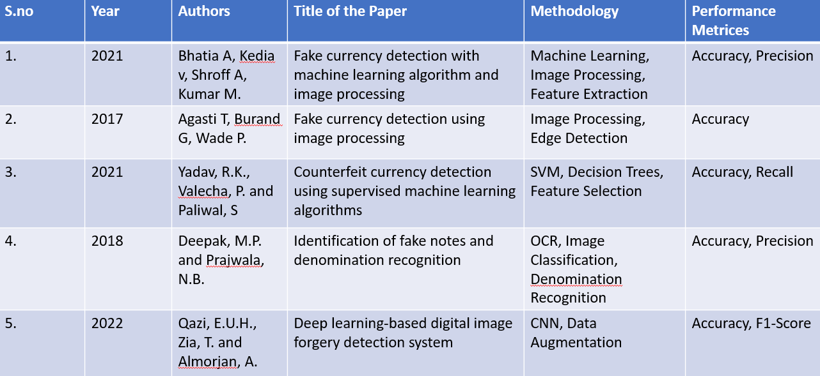

Existing System
Table- 2.1 Literature Survey

Due to the manual nature of fraud detection cash systems and that largely based on machines and hardware, it is not surprising that they are not the most reliable. Manual detection systems involved checking for features such as watermarks, UV images, security threads, but error is always possible, being purely based on visual appearance and experience. Hardware detection which has provided more accuracy is separate and even more expensive. Hardware based systems include UV, Infrared, and magnetic sensors, which can provide reliability.

Limitations of Existing System

Human Error in Manual Checks

High Cost of Hardware Devices

Limited Currency Support

Lack of Portability

Inflexibility to New Forgery Techniques

No Data Logging or Analytics

CHAPTER-3

SOFTWARE REQUIREMENT SPECIFICATION

This chapter gives an overview of the software and hardware components required for our project.

  - SOFTWARE REQUIREMENTS Operating System : Windows 11 Coding Language : Python 3.11
  - HARDWARE REQUIREMENTS System : intel i5
Storage : Sufficient storage

FUNCTIONAL REQUIREMENTS
Here are the functional requirements for the project Fraud Cash Detection Using Image Processing:

    - Image Acquisition

    - Image Preprocessing

    - Feature Extraction

    - Result Display

    - Authenticity Detection

    - Database Storage

    - User Interface

    - Model Update Mechanism

    - Multi-Currency Support

NON-FUNCTIONAL REQUIREMENTS

Here are the non-functional requirements for your project Fraud Cash Detection Using Image Processing:

    - Performance

    - Accuracy

    - Availability

    - Reliability

    - Scalability

    - Security

    - Usability

    - Maintainability

    - Compatibility

  - System Design

CHAPTER-4 SYSTEM DESIGN

In this phase, the system and software design documents are prepared as per the requirement specification document. This helps define overall system architecture.
There are two kinds of design documents developed in this phase:

High-Level Design (HLD)

    - User captures or uploads the image through the front-end UI.
    - Image is sent to the application server via REST API.
    - Server forwards it to the preprocessing module.
    - Preprocessed image is passed to the ML model for prediction.
    - The model returns the result (Real/Fake + Confidence Score).
    - Server stores the result in the database and sends it back to the UI.
    - UI displays the final result to the user.

Low-Level Design (LLD)

    - User uploads image via frontend
    - Backend receives image and calls preprocessing.
    - Preprocessed image is fed to ML model.
    - Model returns result → backend logs it → frontend displays it.
    - Admin/dashboard (optional) can review logs or model stats.

SYSTEM ARCHITECTURE:

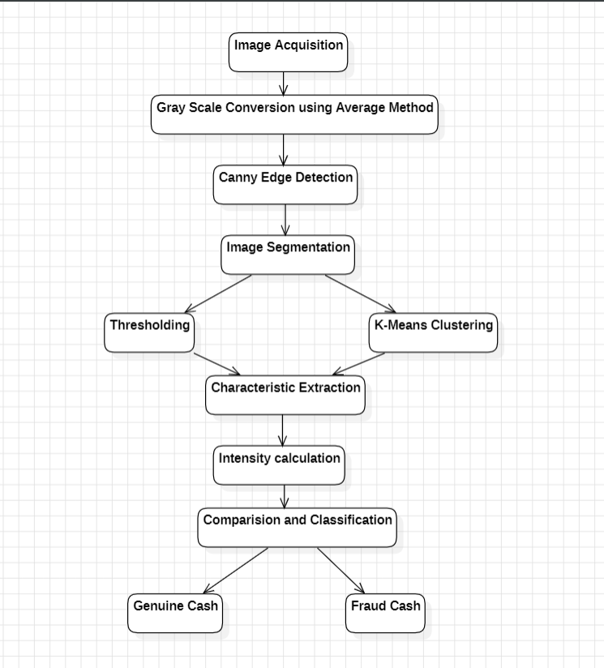
Figure-4.2.1 System Architecture

UML Design:

Unified Modeling Language (UML) is a general-purpose modeling language. The main aim of UML is to define a standard way to visualize the way a system has been designed. It is quite similar to blueprints used in other fields of engineering.
UML is not a programming language; it is rather a visual language. We use UML diagrams to portray the behavior and structure of a system, UML helps software engineers, businessmen and system architects with modeling, design and analysis. The Object Management Group (OMG) adopted Unified Modeling Language as a standard in 1997. It’s been managed by OMG ever since. International Organization for Standardization (ISO) published UML as an approved standard in 2005. UML has been revised over the years and is reviewed periodically.

Do we really need UML?

- Complex applications need collaboration and planning from multiple teams and hence require a clear and concise way to communicate amongst them.
- Businessmen do not understand code. So UML becomes essential to communicate with non-programmer’s essential requirements, functionalities and processes of the system.
- A lot of time is saved down the line when teams are able to visualize processes, user interactions and static structure of the system.
- UML is linked with object-oriented design and analysis. UML makes the use of elements and forms associations between them to form diagrams. Diagrams in UML can be broadly classified as:

The Primary goals in the design of the UML are as follows:

- Provide users a ready-to-use, expressive visual modeling Language so that they can develop and exchange meaningful models.
- Provide extendibility and specialization mechanisms to extend the core concepts.
- Be independent of particular programming languages and development process.
- Provide a formal basis for understanding the modeling language.
- Encourage the growth of OO tools market.
- Support higher level development concepts such as collaborations, frameworks, patterns and components.
- Integrate best practices.

Types of UML Diagrams:

Structural Diagrams:

Capture static aspects or structure of a system. Structural Diagrams include: Component Diagrams, Object Diagrams, Class Diagrams and Deployment Diagrams.

Behavior Diagrams:

Capture dynamic aspects or behavior of the system. Behavior diagrams include: Use Case Diagrams, State Diagrams, Activity Diagrams and Interaction Diagrams.

The image below shows the hierarchy of diagrams according to UML
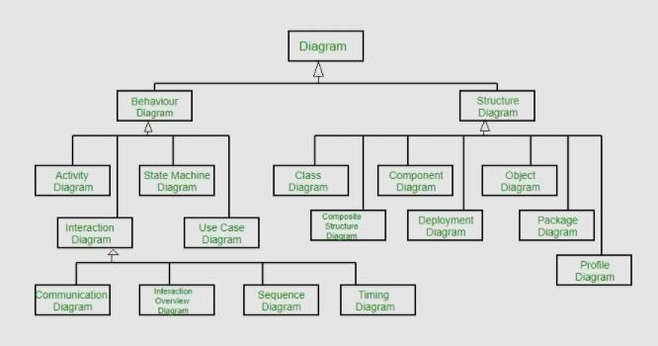

Figure-4.2.1 UML Hierarchy diagrams

ACTIVITY DIAGRAM:
In software engineering, a Activity diagram in the Unified Modeling Language (UML) is a flow chart to represent the flow from one activity to another activity. The activity can be described as a operation of a system. The control flow is drawn from one operation to another. This flow can be sequential, branched or concurrent.

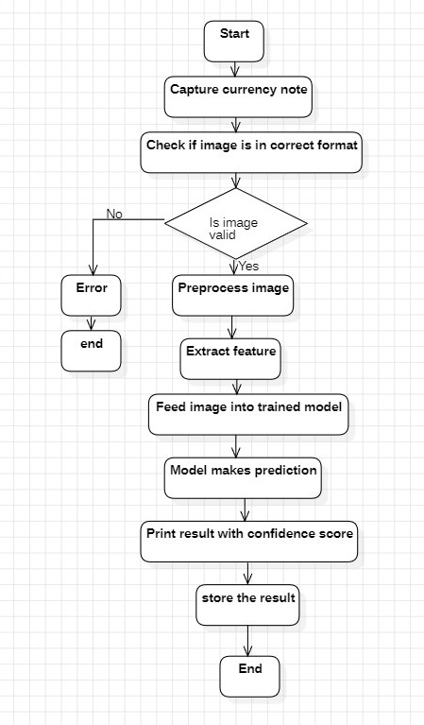
Figure-4.3.1.1 Activity Diagram

USE CASE DIAGRAM:
A use case diagram in the Unified Modeling Language (UML) is a type of behavioral

diagram defined by and created from a Use-case analysis. Its purpose is to present a graphical overview of the functionality provided by a system in terms of actors, their goals (represented as use cases), and any dependencies between those use cases. The main purpose of a use case diagram is to show what system functions are performed for which actor. Roles of the actors in the system can be depicted

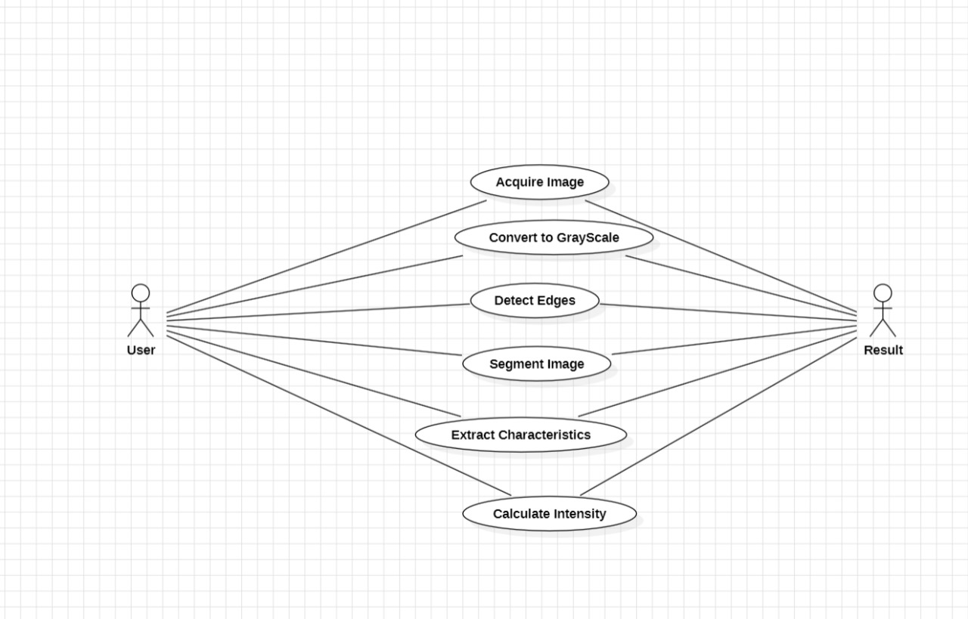

Figure-4.3.2.1 Use Case Diagram

COMPONENT DIAGRAM:
A component diagram, also known as a UML component diagram, describes the organization and wiring of the physical components in a system. Component diagrams are often drawn to help model implementation details and double-check that every aspect of the system's required functions is covered by planned development.

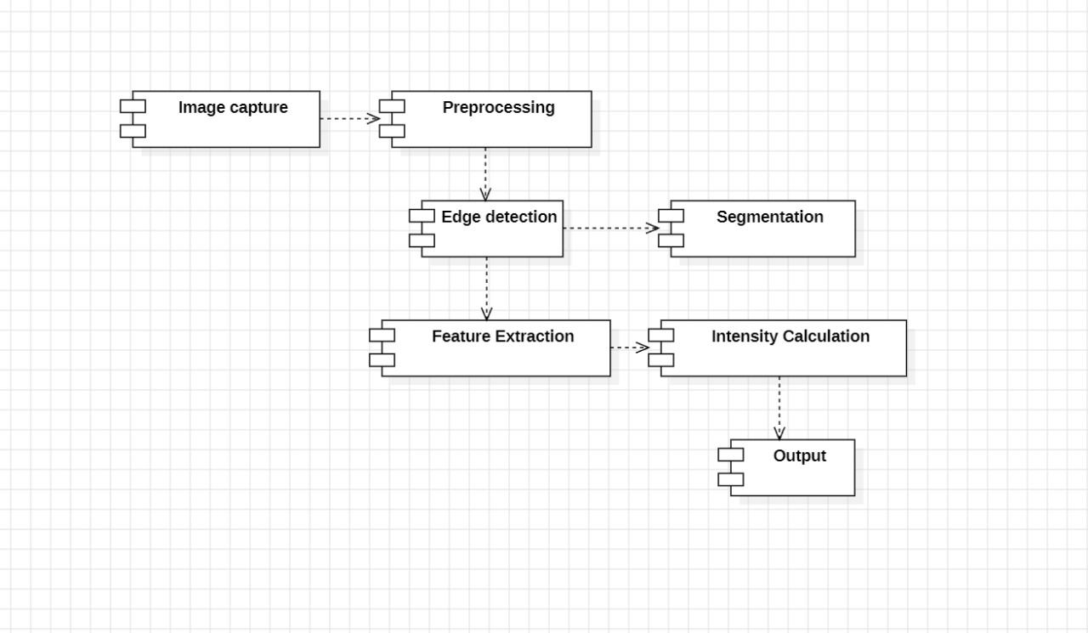
Figure-4.3.3.1 Component Diagram

SEQUENCE DIAGRAM:
A sequence diagram in Unified Modeling Language (UML) diagram that illustrate the sequence of messages between object of an interaction. It consists of a group of objects that are represented by lifelines, and the messages that they exchange over time during the interaction.

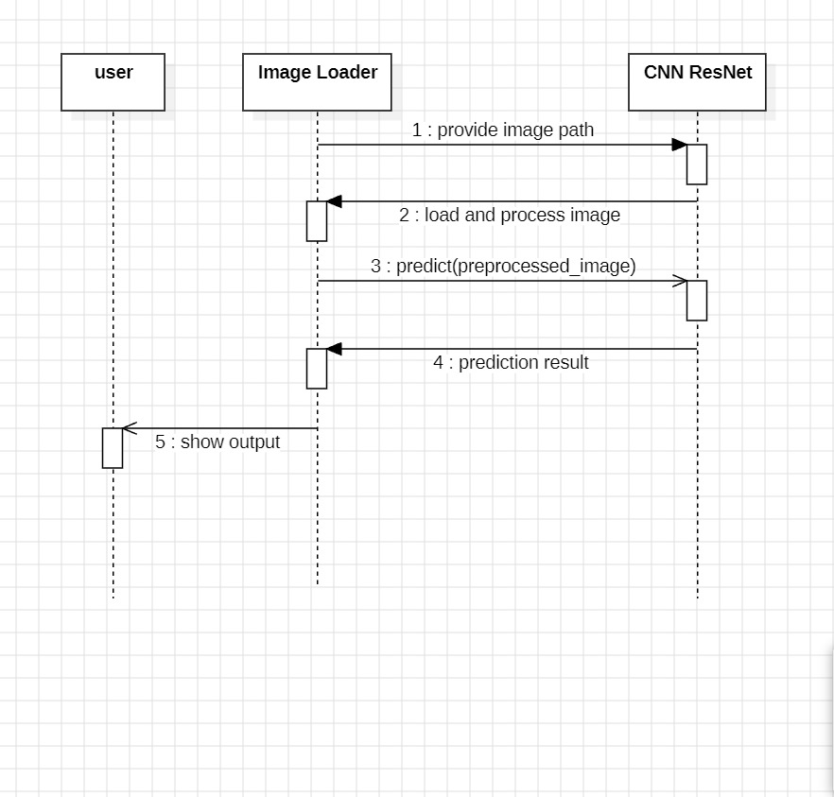

Figure-4.3.4.1 Sequence Diagram

STATE CHART DIAGRAM:
In UML, an State chart diagram is an illustrate of all the possible behavioural states of a software system. Component may be exhibited be exhibit and the various state changes it’s predicted to undergo over the course of its operation.

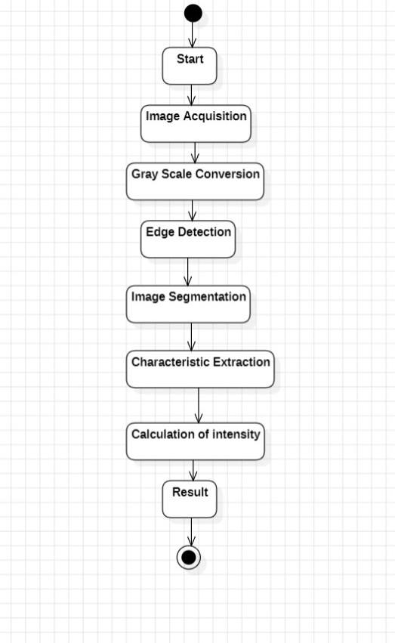
Figure-4.3.5.1 State chart Diagram

TECHNOLOGY DESCRIPTION

Python:
Python is specifically designed for image processing and machine learning tasks - the main components of this project. Since its syntax is also easy to read, Python can be developed faster and allows for debugging more easily - which are all advantageous when executing complex operations such as feature extraction, model training, image classification. Python's libraries can make the transition from raw image input, preprocessing, to classification easier. For example, OpenCV facilitates some pre-processing, NumPy makes numerical calculations easier, and Pandas makes datasets (and therefore other data types) easier to work with. This is vital when moving to complex machine learning frameworks such as TensorFlow, Keras, and Scikit-learn, where models are created and trained to differentiate between real and counterfeit banknotes. All these libraries will seamlessly integrate into Python and provide a more efficient way to complete the build of an accurate and scalable fraud cash detection project.

OpenCV:
OpenCV (Open Source Computer Vision Library) is the most popular open-source library for computer vision and image processing. In our project "Fraud Cash Detection Using Image Processing," OpenCV will be important in processing and manipulating currency note images. It provides high level functions to read images, convert images to grayscale, resize images, blur images, detect edges in images, threshold images, extract features from images, etc., that all prepares the image input for a machine learning model. OpenCV provides optimized functions to perform complicated image operations to facilitate preprocessing to improve the end result and detection accuracy. It also allows the programmer to visualize the image transformation at each stage, which will help debug and validate the input image for the model we create.

NumPy:
NumPy (Numerical Python) is the most important and fundamental library for numerical computations when using Python and works, naturally, with image data produced in OpenCV. NumPy was used in this project to handle image arrays, execute mathematically operations and modify pixel data in an efficient manner. In fact, every image is represented as some matrix of pixel values in memory. NumPy helps with this because it enables direct access to and modification of every image matrix.

Tensorflow or keras:
TensorFlow is an open-source deep learning framework developed by Google that has gained wide acceptance as a general purpose machine learning framework for building and deploying machine learning models. This presentation project has adopted TensorFlow as an important part of developing a convolutional neural network (CNN) capable of being trained to learn complex visual patterns in currency notes, which encodes that content in the form of a multi-layer neural network. Many aspects of developing a CNN model that take lots of work to design, train, drill-down performance, and optimize are simplified with TensorFlow.

Scikit-learn:

Scikit-learn is a helpful and easy-to-use machine learning library in Python, especially for more traditional (non-deep learning) ML techniques. In this project, Scikit-learn can be used as either an alternative to deep learning models, or to complement the models we build using deep learning. It contains various classification algorithms such as Support Vector Machines (SVM), Random Forests, Logistic Regression, and K-Nearest Neighbors (KNN). Each of these algorithms can be applied to hand-designed features extracted from images. It also provides utilities to help split a dataset into training and validation/test sets, is helpful for evaluating model performance, cross-validating models, and scaling the features.

Pandas:

Pandas is a versatile data manipulation and analysis library for Python that was used in this project to perform dataset operations on currency images. It provides utilities for organizing image labels, entering prediction results, and managing training logs in structured tabular configurations.

Matplotlib:
Matplotlib is a popular plotting library in Python and a key tool for visualizing the various aspects of the performance of the model. The fraud cash detection project will use Matplotlib to plot training accuracy and loss curves and to plot the confusion matrices.

Google Colab:
Google Colab is a free, cloud-based development environment offered by Google that allows users to write and execute Python code in the browser. It is particularly good for machine learning and image processing applications like fraud cash detection. Google Colab provides free access to GPUs and TPUs, which increase the execution speed, which also increases model training speed.

CHAPTER 5

IMPLEMENTATION

Objectives and scope:
The overarching aim of this project is to establish a smart and efficient system capable of identifying counterfeit currency accurately using image processing techniques and machine learning. The system intends to analyze a currency note's features, including watermark patterns, color tones, symbols, and texture, through its image process whether a note is real or counterfeit.

Gather Data Sets:
Acquiring the correct dataset is an important step to realistically develop a reliable and accurate Fraud Cash Detection application. From the perspective of training a model, it is important that we define 'fake' notes for our model to distinguish from 'real' notes so our dataset consists of plenty of clear images of both classes in different conditions.

Set up Development Environment:
In order to create the Fraud Cash Detection Using Image Processing project, you will need access to a Python environment that contains libraries such as OpenCV (for image processing), NumPy (for numerical operations), TensorFlow/Keras (for building the model), Scikit-learn (for Machine Learning algorithms), Pandas (for handling data), and Matplotlib (for visualization).

Preprocess Data Image Processing:
During the image preprocessing process, the raw images of currency notes are transformed into suitable outputs for mapping to real-valued dimensions for analysis using image processing libraries like OpenCV and NumPy. Each one of the images is converted to grayscale first, which simplifies the information down to one channel while still retaining the structural information needed by the model.

Feature Selection:
Significant features are identified from the preprocessed images to use in the machine learning model to distinguish between the fake and real currency notes. The features calculated using OpenCV include edges, texture, color intensity, contours, etc. Thereafter, these computed values are structured (e.g. NumPy array or Panda Data Frame) and can be used to input as a vector into the machine learning algorithm.
Model building:
Then, a machine learning model is trained using those features via algorithms (e.g. Support Vector Machine (SVM), Random Forest, Logistic Regression) from the Scikit-learn library. The machine learned the patterns of real and fake currency notes by analyzing the feature values from all the training data.
Model training:
The dataset will be divided into both training and testing sets - to develop a model, we will train the model based on the training data. The model learns to classify notes, given all the features. The model makes sure that before it begins classifying based on notes to predictions, it will adjust the parameter to minimize error and achieve the maximum accuracy.
Model evaluation:
After the model is trained, the model is evaluated on the test data. The model is evaluated against several performance metrics (i.e., accuracy, precision, recall, and F1-score) and is visualized through a confusion matrix, indicating how many real and fake notes were classified as either real or fake (correctly or incorrectly).
Prediction and testing:
Finally, the trained model is used to classify new images. A new image is preprocessed, and its features are extracted the same way as before, and then transferred to the model for prediction. The model will tell you if the currency note appears to be real or fake based on the patterns it learned.

MODULES:
    - Image Acquisition Module:
This module is responsible for capturing or importing images of currency notes. Images can be captured by means of a camera, scanned or uploaded from data set. It makes sure that the images that is entered into this module will maintain the correct image format and image quality for further processing.

Image Preprocessing Module:
This module performs operations such as grey-scaling images, resizing, noise reduction, edge detection, and normalization. These steps improve image quality for effective feature extraction or input to the model directly.

    - Feature Extraction Module:
A key aspect of this module is the extraction of relevant visual features from the image, such as contours, color histograms, texture patterns and key points. These features allow the model to identify distinct characteristics of real or fake notes.

    - Model Training Module:
In this module, you have to choose and train your machine learning or deep learning model using the pre-processed images or feature extraction. The algorithms, like SVM, CNNs, etc. will be trained to differentiate between genuine and counterfeit notes.

Prediction Module:

This module uses the trained model to make predictions on currency images that are new or unknown. It outputs whether the currency is authentic, or whether it is counterfeit based on the patterns that it has learned.

Evaluation Module:
In this module, we evaluate the performance of the model using metrics such as accuracy, precision, recall, F1-score, and confusion matrix. This module allows us to examine if the model is distinguishing real notes from fake notes.

  - EXECUTABLE CODE

from tensorflow.keras.layers import Input, Lambda, Dense, Flatten
from tensorflow.keras.models import Model
from tensorflow.keras.preprocessing import image
from tensorflow.keras.preprocessing.image import ImageDataGenerator,load_img
from tensorflow.keras.models import Sequential
from tensorflow.keras.layers import MaxPooling2D
from tensorflow.keras.layers import Conv2D
import numpy as np
from glob import glob
import os
from google.colab import drive
drive.mount('/content/drive')
# re-size all the images to this
IMAGE_SIZE = [224, 224]
# Assuming your dataset is directly in the specified folder on your Google Drive
train_path = '/content/drive/MyDrive/dataSet/Train'
valid_path = '/content/drive/MyDrive/dataSet/Test'
# Verify the directories exist
if not os.path.exists(train_path):
print(f"Error: Training directory not found at {train_path}")
if not os.path.exists(valid_path):
print(f"Error: Validation directory not found at {valid_path}")
# useful for getting number of output classes
folders = glob('/content/drive/MyDrive/dataSet/Train/*')
import matplotlib.image as mpimg
from glob import glob
import os
import matplotlib.pyplot as plt
train_image_files = glob(os.path.join(train_path, '*/*.jpg'))

# Display some sample images from the training directory
num_images_to_display = 5
for img_path in train_image_files[:num_images_to_display]:
img = mpimg.imread(img_path)
plt.imshow(img)
plt.axis('off')
plt.show()
import os
from tensorflow.keras.preprocessing import image
from tensorflow.keras.preprocessing.image import ImageDataGenerator
from tensorflow.keras.applications.mobilenet import MobileNet
from tensorflow.keras.applications.mobilenet import preprocess_input
from tensorflow.keras.layers import Dense, GlobalAveragePooling2D
from tensorflow.keras.models import Model
from tensorflow.keras.optimizers import Adam

datagen = ImageDataGenerator(rescale=1./255, shear_range=0.2, zoom_range=0.2, horizontal_flip=True)
train_set = datagen.flow_from_directory(train_path, target_size=(IMAGE_SIZE[0], IMAGE_SIZE[1]), batch_size=32, class_mode='categorical')
valid_set = datagen.flow_from_directory(valid_path, target_size=(IMAGE_SIZE[0], IMAGE_SIZE[1]), batch_size=32, class_mode='categorical')

# Load MobileNet model with pre-trained weights, excluding the top (fully connected) layers
base_model = MobileNet(weights='imagenet', include_top=False)
# Add custom top layers for classification
x = base_model.output
x = GlobalAveragePooling2D()(x)
x = Dense(1024, activation='relu')(x)
x = Dense(1024, activation='relu')(x)
x = Dense(512, activation='relu')(x)
preds = Dense(len(folders), activation='softmax')(x) # Assuming one node for each class

# Create the model
model = Model(inputs=base_model.input, outputs=preds)

# Compile the model
# Changed 'lr' to 'learning_rate'
model.compile(optimizer=Adam(learning_rate=0.0001), loss='categorical_crossentropy', metrics=['accuracy'])

# Train the model
hist=model.fit(train_set, validation_data=valid_set, epochs=10, steps_per_epoch=len(train_set), validation_steps=len(valid_set))
import matplotlib.pyplot as plt
plt.plot(hist.history['accuracy'], label='Training Accuracy')
plt.plot(hist.history['val_accuracy'], label='Validation Accuracy')
plt.title('Training and Validation Accuracy')
plt.xlabel('Epoch')
plt.ylabel('Accuracy')
plt.legend()
plt.show()
model.save("fake_currrecy_detection.h5")
# Load the saved model
import tensorflow as tf
loaded_model = tf.keras.models.load_model('/content/drive/MyDrive/dataSet/fake_currrecy_detection.h5')
test_image_path = '/content/drive/MyDrive/dataSet/Test/1Hundrednote/1.jpg' # Change this to the path of your test image

# Load the test image
test_img = image.load_img(test_image_path, target_size=IMAGE_SIZE)
test_img_array = image.img_to_array(test_img)
test_img_array = np.expand_dims(test_img_array, axis=0) # Add batch dimension

# Normalize the image data
test_img_array = test_img_array / 255.0

# Make prediction
predictions = loaded_model.predict(test_img_array)

# Class labels
class_labels = ['Fake', 'Real']

# Get the predicted class label
predicted_class_index = np.argmax(predictions[0])
predicted_class_label = class_labels[predicted_class_index]

print("Predicted class:", predicted_class_label)
from tensorflow.keras.models import Sequential
from tensorflow.keras.layers import Conv2D, MaxPooling2D, Flatten, Dense
from tensorflow.keras.optimizers import Adam
# Assuming you have already defined 'folders' earlier using glob
num_classes = len(folders) # Get the number of classes from your earlier definition

# Define the CNN model for multi-class classification
model = Sequential([
Conv2D(16, (3, 3), activation='relu', input_shape=(224, 224, 3)),
MaxPooling2D((2, 2)),
Conv2D(32, (3, 3), activation='relu'),
MaxPooling2D((2, 2)),
#Conv2D(128, (3, 3), activation='relu'),
#MaxPooling2D((2, 2)),
Flatten(),
Dense(120, activation='relu'),
# Changed the output layer for multi-class classification
Dense(num_classes, activation='softmax') # Output layer with 'num_classes' nodes and softmax activation
])

# Compile the model
# Changed loss function for multi-class classification
model.compile(optimizer='adam',
loss='categorical_crossentropy', # Use categorical_crossentropy for multi-class
metrics=['accuracy'])

# Display model summary
model.summary()

# Train the model
# This should now work with the existing multi-class train_set and valid_set
history = model.fit(train_set, epochs=5, validation_data=valid_set)

# Save the trained model
model.save("cnn_model.h5")
from tensorflow.keras.applications import ResNet50
from tensorflow.keras.models import Model
from tensorflow.keras.layers import Dense, GlobalAveragePooling2D

# Load the pre-trained ResNet50 model
base_model = ResNet50(weights='imagenet', include_top=False)

# Add custom classification layers on top
x = base_model.output
x = GlobalAveragePooling2D()(x)
x = Dense(128, activation='relu')(x)
# Changed the output layer for multi-class classification
# Use 'num_classes' (which should be 7) and 'softmax' activation
# Assuming 'folders' and thus 'num_classes' are defined earlier
num_classes = len(folders) # Ensure num_classes is defined, though it likely is from earlier cells
predictions = Dense(num_classes, activation='softmax')(x)

# Combine the base model with custom classification layers
model = Model(inputs=base_model.input, outputs=predictions)

# Freeze the base model layers
for layer in base_model.layers:
layer.trainable = False

# Compile the model
model.compile(optimizer='adam',
# Changed loss function for multi-class classification
loss='categorical_crossentropy',
metrics=['accuracy'])

# Train the model
history = model.fit(train_set, epochs=5, validation_data=valid_set)

# Save the trained model
model.save("resnet_model.h5")
import seaborn as sns
import matplotlib.pyplot as plt

# Extract accuracies from the training history of each model
mobile_acc = hist.history['accuracy'][-1] # Taking the final accuracy value
cnn_acc = history.history['accuracy'][-1] # Taking the final accuracy value
resnet_acc = history.history['accuracy'][-1] # Taking the final accuracy value

# Create a DataFrame
data = {
'Model': ['Proposed_model', 'CNN', 'ResNet50'],
'Accuracy': [mobile_acc, cnn_acc, resnet_acc]
}

# Create a bar plot using Seaborn
plt.figure(figsize=(10, 9)) # Increase plot size
sns.barplot(x='Model', y='Accuracy', data=data)

# Add title and labels
plt.title('Comparison of Model Accuracies')
plt.xlabel('Model')
plt.ylabel('Accuracy')

plt.show()
import os
from google.colab import drive

drive.mount('/content/drive')
# Load the saved model
import tensorflow as tf
from tensorflow.keras.preprocessing import image
import numpy as np
from glob import glob
IMAGE_SIZE = [224, 224]

loaded_model = tf.keras.models.load_model('/content/drive/MyDrive/dataSet/fake_currrecy_detection.h5')
test_image_path = '/content/drive/MyDrive/dataSet/Test/1Hundrednote/1.jpg' # Change this to the path of your test image
# Load the test image
test_img = image.load_img(test_image_path, target_size=IMAGE_SIZE)
test_img_array = image.img_to_array(test_img)
test_img_array = np.expand_dims(test_img_array, axis=0) # Add batch dimension
# Normalize the image data
test_img_array = test_img_array / 255.0
# Make prediction
predictions = loaded_model.predict(test_img_array)

# Class labels
class_labels = ['Fake', 'Real']

# Get the predicted class label
predicted_class_index = np.argmax(predictions[0])
predicted_class_label = class_labels[predicted_class_index]

print("Predicted class:", predicted_class_label)

6.1 Introduction to testing:

CHAPTER -6 TESTING

Testing is an important part of the software development lifecycle that assures the project's functionality, dependability, and accuracy. In the case of the Fraud Cash Detection Using Image Processing system, it is a process that checks if all modules, such as image processing and applying the model for predication, can do what they are intended to do. It can also be used to find and correct errors, validate that the model can distinguish between a real and fake currency note, and verify the system operates consistently under a range of conditions. There is both functional and non-functional testing conducted to check system output, the performance of system features, and sensitivity to changes (robustness). By spending time conducting thorough tests which consequently boost assurance in the accuracy and reliability of eventual outcomes (e.g. correct decision making concerning classification of money as either real or fake), will be important in maximizing security and accuracy of any system when used in practice.

Unit Testing:
Unit testing is a way of testing software to evaluate individual program components or functions in isolation from the other parts of the program. In terms of the Fraud Cash Detection Using Image Processing project, unit-testing is testing some specific function, for instance checking the image preprocessing (resize, convert to grayscale etc), feature extraction methods separately, or the model prediction function separately. The purpose of automatically running unit-test is to detect bugs earlier by testing the smallest testable parts of code separately, for example, you may have a unit test that makes sure the image normalization divides pixels between 0 and 1.

6.2.2. Integration Testing:
Integration testing checks how well the pieces of a system work together. In the Fraud Cash Detection Using Image Processing project, this means checking how the image preprocessing module works with the feature extraction module, how those outputs are passed to the machine learning model, and how the prediction output is handled. For example, it would check that the image that goes through preprocessing is in an acceptable format for the model and whether it can be used without configuration errors. This is useful to find if there are any problems in that data is not matching up correctly, calls to functions in other modules are incorrect, or that communication through components has failed. Integration testing determines whether the end-to-end work flow functions, from the image input through to classification output, correctly.

6.2.3. Functional Testing:
Functional testing is a category of software testing that verifies that the system actually behaves according to the stated requirements and fulfills all intended functions properly. In the Fraud Cash Detection Using Image Processing project, the functional testing was utilized to prove that essential functionalities were working as expected: uploading an image, pre-processing that image, classifying the image using our trained model, and outputting whether the currency is real or fake. Each function was tested by giving it input and checking to see if it produced the appropriate output. For example, we input a fake currency image, and the system confirmed it was fake. Functional testing verifies what the system does, not how it does it, and usually takes into account the user requirements and the use cases.
CHAPTER - 7
RESULTS

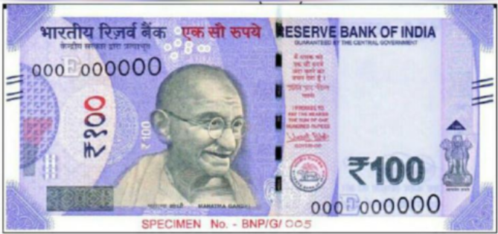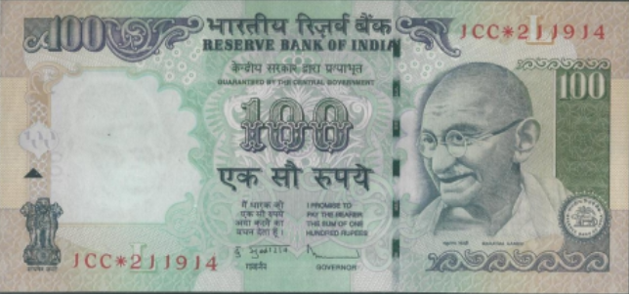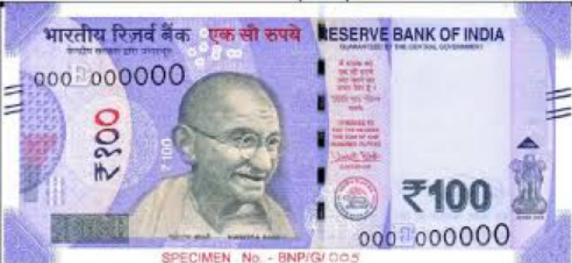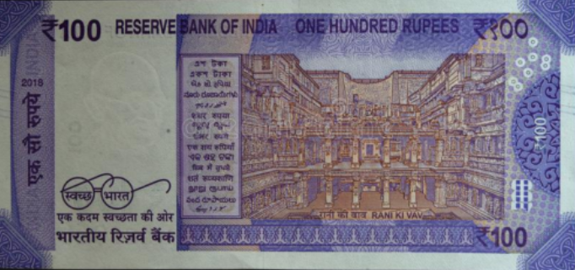

Figure-7.1 Input

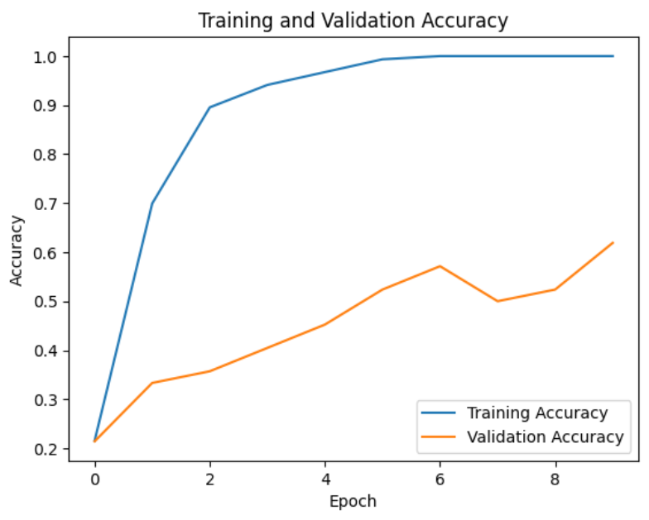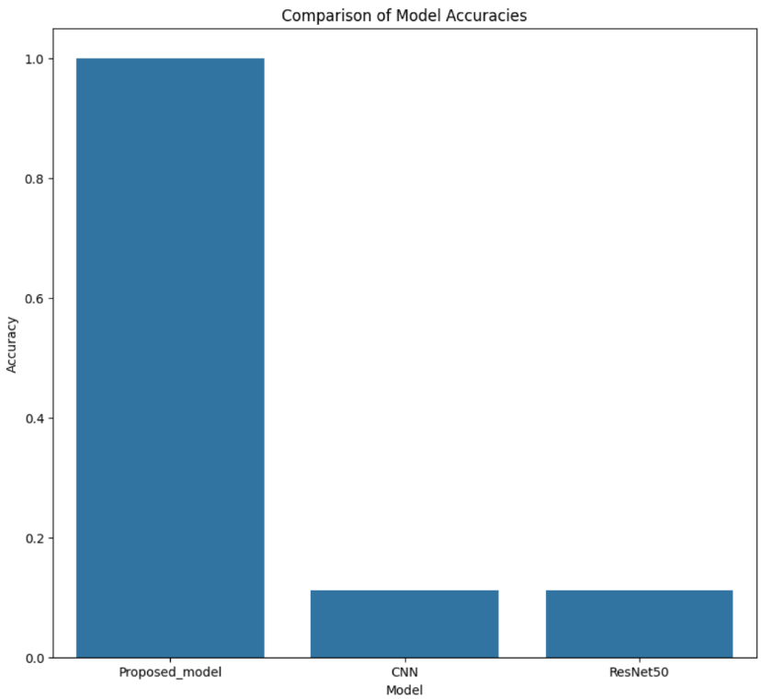

Figure-7.2 Output

CHAPTER 8

  - CONCLUSION

A project called Fraud Cash Detection Using Image Processing demonstrates the potential applicability of computer vision and machine learning to detect the counterfeit currency notes in a fast and efficient way. Computer vision has distinctive property in the ability to visualize, and train a model through classification based on the existence of differing technologies such as OpenCV which enables preprocessing of the images, and TensorFlow or Scikit-learn which enables training of the models. Our project will determine the currency images to be either real or fake based on indicating meaningful visual features of currency images. The project has advanced on ancient, manual methods of detection as well as developed a remedy that will be used in financially checking in an automated, scalable, and more trust-worthy manner. It does more than just reduce the chances of human error; it also enhances financial verification systems. This has practical application in real life in the banks, businesses, and the ATM machines which offer a mode of monetary dealings in a much safer and secure way.

FUTURE SCOPE

It would be better if the project could be enhanced to support multiple currencies and integrated to be used in mobile applications or banks to detect counterfeiting in real-time. Larger data sets, more advanced deep learning models, and UV/IR imaging would contribute towards accuracy. It could also likely be used in ATMs, POS machines, or even a cloud-based service to be used for fraud detection on a large scale.

REFERENCES
1.“Currency Detection and Recognition Based on Deep Learning” by Q. Zhang and W. Q. Yan (published on IEEE)
2.“Fake Currency Detection” by S. Arya and M. Sasiku mar (published on ICRAECC)

PLAGIARISM CHECK:

